Cawdor Public School 1537

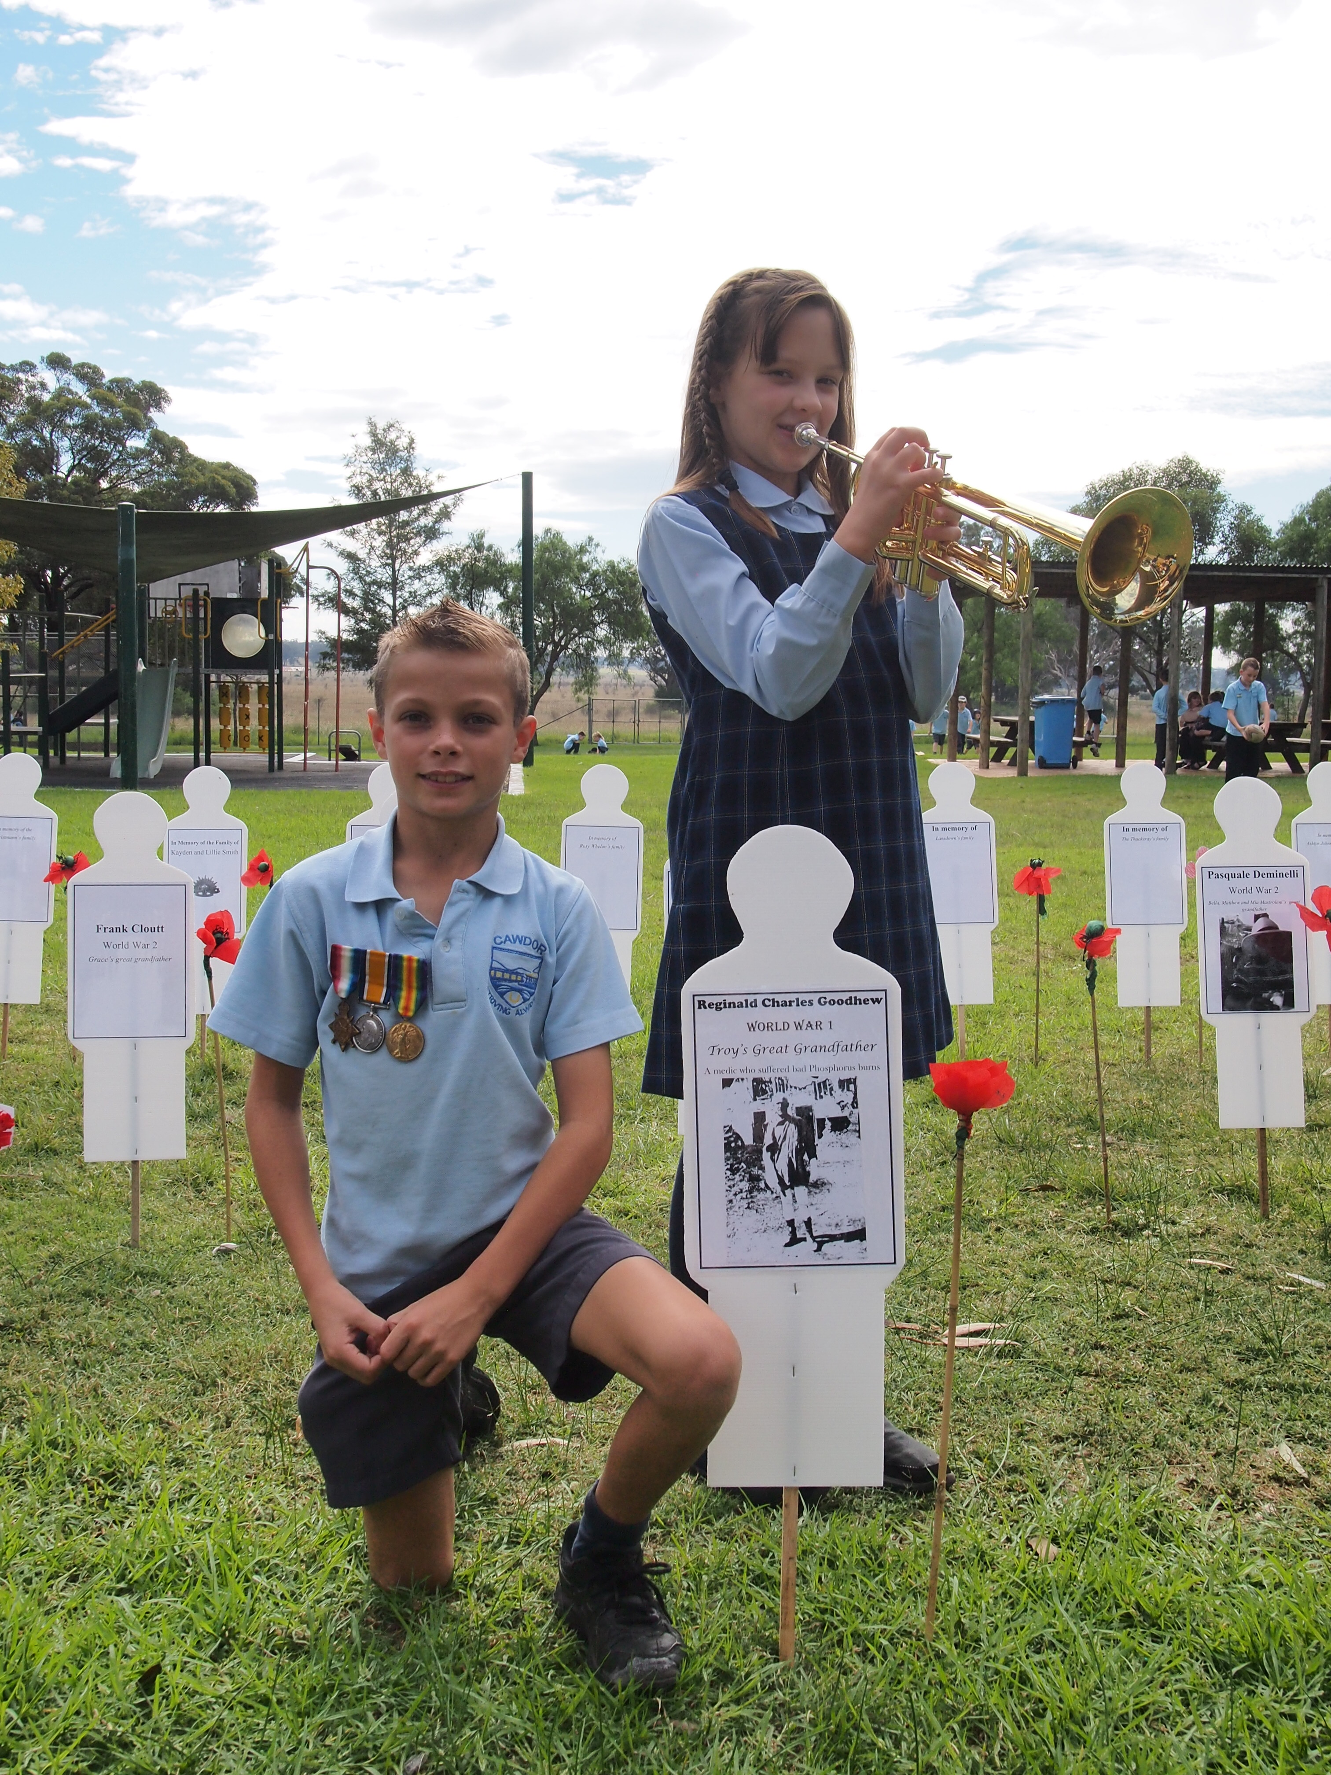
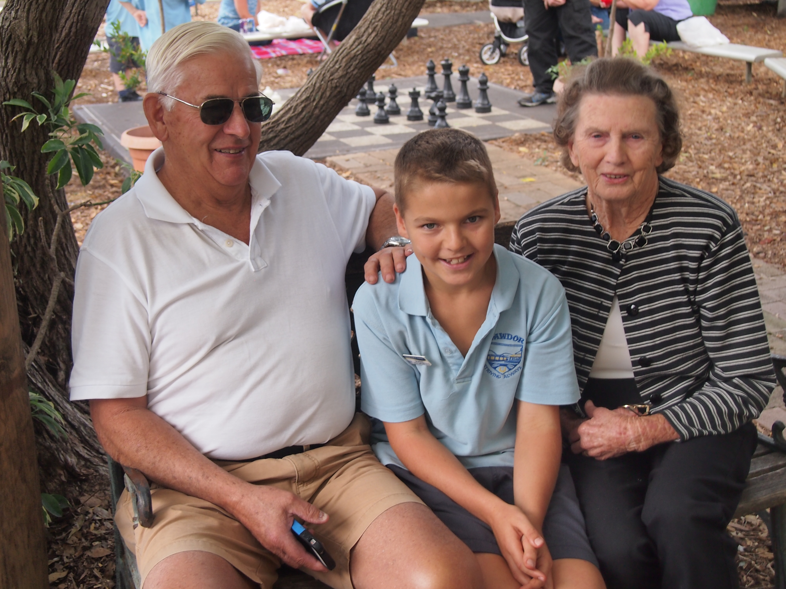
Quality, innovative
teaching

Enhanced student
wellbeing and mindfulness
Creative and engaging learning
School vision statement |  | School context |  | School planning process
At Cawdor Public School we are striving to create a bright future.  In a nurturing environment, staff, parents and the wider community are working in close partnership to foster a life-long love of learning and a strong sense of citizenship. We are dedicated to providing an innovative, purposeful and differentiated education so that our students can reach their full potential and successfully take their place as informed, happy and mindful citizens in a complex and changing world. |  | Cawdor Public School is a small school, situated in a beautiful semi-rural setting close to Camden. Established in 1858, the school has a rich history and has been a focal point in the area for over 150 years. The school is appreciated for its caring family atmosphere and high levels of community involvement.  78 students, predominantly of White Anglo-Saxon background, currently attend the school. The school population also includes 5 Aboriginal students.  The community at Cawdor is highly committed to providing a nurturing and innovative learning environment in which each student is encouraged to become an informed and responsible citizen. The wellbeing of every student is a high priority and the learning programs focus on the individual needs of each child.  Environmental Education and sustainability are a major focus at Cawdor. The school is a member of the local Sustainable Schools Network and in 2014 the school joined the Eco Schools program.  Student leadership is also strongly promoted in the school. There are many opportunities for students to take on leadership roles. Students attend leadership workshops throughout the year and the older students take an active role in the care and education of the younger students.  Cawdor is also part of a small schools’ network known as the Community of Best Practice. The schools in the community have formed strong links to provide Professional Learning opportunities for the teachers and also for sporting events, excursions and learning opportunities such as science fairs and writing workshops. The school is also actively involved in an effective high school links program with the Camden Community of Schools. |  | In 2014, a comprehensive and consultative process was undertaken to review current practices and to gather ideas from students, staff and parents for our school’s educational programs in the next three years.  Student forums in each class were undertaken and surveys were completed by staff and parents. Discussions also took place at P&C and School Council meetings. The forums, discussions and surveys gave all our community members the opportunity to give their opinions on current programs, priorities in education, suggestions for improvements and dreams for the future of the school.  The teachers also reviewed data and evidence of student achievement of outcomes.  At two evening meetings and subsequent staff meetings the staff collated the data and results of surveys and took part in in-depth discussions about directions for Cawdor PS. As a result, we were able to develop our school vision, and three strategic directions:  - Quality, innovative teaching  - Creative and engaging learning  - Enhanced student wellbeing and mindfulness  The vision and directions were communicated to the parents in newsletters and at a P&C meeting.  The Cawdor School Plan is driven by the strategic directions and sets clear improvement measures.  Each strategic direction provides details of the purpose, people, processes, practices and products that are to be realised through the implementation of the plan, in partnership with parents, community and other partner schools.

STRATEGIC DIRECTION 1  Quality, innovative teaching |  | STRATEGIC DIRECTION 2  Creative and engaging learning |  | STRATEGIC DIRECTION 3  Enhanced student wellbeing and mindfulness
Purpose:  To ensure quality learning across the school by building the capacity of all staff, inspiring them to work collaboratively to deliver high standard, relevant and engaging educational programs. |  | Purpose:  To work together as a learning community to enable the students to become creative, critical thinkers and problem solvers who are able to lead successful lives in the 21st Century. |  | Purpose:  To nurture the students, providing them with the skills to be confident and to develop a healthy and positive lifestyle as active, informed and respectful citizens.

Strategic Direction 1: Quality Innovative Teaching

Purpose |  | People |  | Processes |  | Products and Practices
To ensure quality learning across the school by building the capacity of all staff, inspiring them to work collaboratively to deliver high standard, relevant and engaging educational programs. |  | Students:  Provide students with new strategies to understand their own learning, to gain deeper engagement and improved outcomes.  Staff:  Increase staff capability to deliver quality, engaging teaching programs to improve student outcomes, through planned, personalised professional learning activities.  Parents/Carers:  Build awareness and understanding of 21st Century learning pertaining to new syllabus outcomes and content, including ideas and strategies for parents in supporting the learning of their children.  Community Partners:  Further enhance Community of Schools partnerships to support professional learning.  Consistent communication between external agencies involved in the care and welfare of all students.  Leaders:  Ensure support and inspire implementation of new pedagogies and strategies. Demonstrate instructional leadership promoting and modelling effective evidence based best practice.  Build staff capabilities, providing opportunities for teachers to develop their leadership skills. |  | Further build staff capacity to effectively implement new syllabuses through ongoing professional learning and networking across the community of small schools and the development of scope and sequences in English and Mathematics.  Develop staff knowledge of current educational practice and encourage research and involvement in innovative learning projects.  Develop a culture of collaborative planning, mentoring, resource sharing and reflection of teaching practices.  Further develop teachers’ understanding of formative assessment practices and analysis of assessment data.  Enhance parent understanding of 21st Century learning through Parents as Partners workshops and parent involvement in student learning.  Evaluation Plan:  Evidence collected through collaborative Performance and Development Framework plan  Analysis of NAPLAN data and school based assessments  Evaluation surveys related to curriculum implementation |  | Products:  Teaching and Learning programs that include a high level of 21st century learning, demonstrate a clear purpose for students and include differentiated learning experiences.  All teachers demonstrating confidence and abilities to implement syllabus documents.  Sustained student growth along the literacy and numeracy continuums.  Teachers achieving accreditation at proficient or higher levels in line with career goals.  Practices:  Demonstrated quality implementation of the new NSW English, Mathematics, Science & Technology and History syllabuses for the Australian curriculum, using newly developed scope and sequences.  Daily evidence of 21st Century innovative teaching and learning practices to highly engage students.  Consistent and meaningful assessment practices driving quality teaching and learning programs.  Staff setting and reflecting on their professional learning goals, in line with the Performance and Development Framework.
Improvement Measures
- All teachers implementing the core competencies of new syllabus documents.

- All teachers demonstrating effective assessment practices and quality innovative teaching of differentiated curriculum .

- 85% of students achieving stage expectations based on PLAN data and school-based assessments.

- All students demonstrating sustained growth along the literacy and numeracy continuums.

Strategic Direction 2: Creative and Engaging Learning

Purpose |  | People |  | Processes |  | Products and Practices
To work together as a learning community to enable the students to become creative, critical thinkers and problem solvers who are able to lead successful lives in the 21st Century. |  | Students:  Fully engage students in 21st Century learning of goal setting, collaborative problem solving, critical thinking and creativity to foster a lifelong love of learning.  Staff:  Build the staff knowledge of 21st Century learning and increase the confidence and expertise of staff to explore innovative and creative teaching and learning programs.  Parents/Carers:  Invite and encourage parents to actively participate in the children’s learning.  Community Partners:  Continue to develop inter-school relationships to provide platforms for professional dialogue, sharing of ideas, reflective practices and mentoring.  Leaders:  Identify and develop expertise of all staff and encourage teachers to take on leadership roles in innovative practice across the curriculum. |  | Develop the intellectual and imaginative capacity of students through the exploration of 21st century learning skills to create inquiring, confident self-motivated learners.  Include a focus on local history and local and global issues in teaching and learning programs to make learning relevant and engaging.  Further build the capacity of staff to effectively use technology to support innovative teaching and learning.  Provide opportunities for students to engage in learning to develop their interests and talents, utilising staff, parent and community member expertise.  Develop students’ understanding of their own learning through goal setting, verbalising learning intentions and relection on personal goals.  Develop and implement programs specifically targeted to increase learning engagement of Aboriginal students.  Evaluation Plan:  School surveys in regard to student engagement  Classroom observations  Monitor with staff at staff meetings |  | Products:  Increased levels of student engagement in learning as indicated by annual surveys of students, parents and staff.  90% or more of students responding positively to survey questions in regard to enjoyment of school and learning.  Improved learning outcomes, with 85% of students achieving at or above stage expected outcomes.  Practices:  Students successfully setting and reflecting on personal goals.  Teaching and learning that is relevant to the students and that promotes high level student engagement and the opportunity for student ownership of learning.  Students working collaboratively and applying knowledge, reasoning and creativity in all KLAs.  Parents/Carers actively participating in children’s learning and sharing their expertise with the students.  Flexible teaching practice that embraces valuable learning opportunities as they arise.  Teaching and learning programs implemented that focus more on local and global issues.
Improvement Measures
- All students engaged in formulating and reflecting on their own learning goals.

- 90% or more of students responding positively to survey questions in regard to enjoyment of school and learning.

- Improved learning outcomes, with 85% of students achieving at or above stage expected outcomes.

Strategic Direction 3: Enhanced Student Wellbeing and Mindfulness

Purpose |  | People |  | Processes |  | Products and Practices
To nurture the students, providing them with the skills to be confident and to develop a healthy and positive lifestyle as active, informed and respectful citizens. |  | Students:  Increase student involvement in personal development programs, leadership roles and community projects.  Staff:  Build staff knowledge of holistic approaches to education, including strategies and programs that enhance the development of each child academically, socially and emotionally.  Parents/Carers:  Maximise involvement of parents in the development of student IEPs and PLPs.  Provide parents/carers with knowledge of positive behavioural strategies and student welfare programs and involve parents/carers in school and community programs.  Community Partners:  Enhance support and links with community groups to utilise mentors and expertise.  Leaders:  Promote the core values and set high expectations of all stakeholders.  Research current educational practice and provide opportunities for professional dialogue in regard to student wellbeing. |  | Whole community involvement through consultation in the development of student welfare programs.  Professional learning for staff in catering for the needs and ensuring the wellbeing of all students.  Provide further opportunities for students to be involved in leadership roles and in buddy programs.  Continued involvement in environmental programs leading to greater awareness of sustainability as global citizens.  Professional learning in mindfulness programs such as Mindup and the daily implementation of the programs across the school to ensure a consistent approach to maintaining student wellbeing.  Provide increased opportunities for students to be involved in local community projects to develop greater sense of citizenship.  Evaluation Plan:  Surveys of staff and parents/carers  Student forums and surveys  Evaluation sessions at student council meetings |  | Products:  All students displaying increased mindful and positive behaviour.  Increased school participation in community projects that enhance student citizenship.  Quality IEPs and PLPs which are reflective of the whole child’s academic, social and emotional needs.  Attainment of Bronze level in the Eco Schools program.  Practices:  Students actively involved in leadership roles and working collaboratively with others.  Students relating to others respectfully, calmly and with an increased awareness of the needs of others.  Whole school involvement in environmental programs, developing understanding of the importance of sustainability practices.
Improvement Measures
- All students displaying increased mindful and positive behaviour.

- School participation in community projects each term that enhance student citizenship.

- Quality IEPs and PLPs for all students requiring learning adjustments.

- Attainment of Bronze level in the Eco Schools program.

