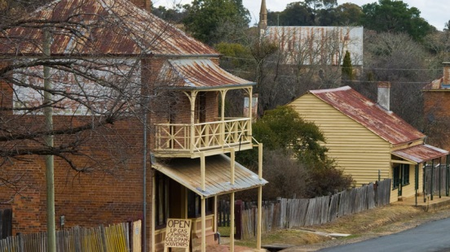
STAGE 3 GOLDFIELDS EXCURSION 16-18 MAY 2016
Dear Parents and Caregivers,
A three day excursion to Hill End and Bathurst has been planned for students in Year 5 and 6 from Cawdor and Douglas Park schools from Monday 16 May to Wednesday 18 May. We have organised some interesting activities to enhance our units of work this year, in particular the history of the Goldfields in Australia which we will be studying next term. We have arranged to stay both nights at the Hill End Holiday Ranch at Hill End. The adults accompanying this excursion will be Ms Ihlein (Cawdor PS) and Mr Paterson and Mrs Roche (Douglas Park PS).
Outlined below is an overview of the excursion and the full cost.
Cawdor PS will be subsidising our students to bring the cost down to $245 each. This covers coach travel, dinner, bed and breakfast accommodation at Hill End Holiday Ranch and all entry fees and lunches on Days 2 and 3. We will be travelling with Hunts Coaches, Camden.
If you would like your child to attend please complete the permission note and medical note and return both to the office with payment. A deposit of $50 is required by Friday 18th March to secure a position.
Payments may be made by instalments. Please contact Ms Ihlein if financial assistance is required. All money must be paid by Monday 9th May. Payment may be made by cash, cheque, credit card or EFT.
ITINERARY
Day 1 Tuesday 16 May
7.00am Arrive at school, ready to depart at approx. 7.15am
9.00am Morning tea and a visit to Scenic World, Katoomba (railway, rainforest walk, cable car ride)
Proceed to Bathurst for lunch (children bring own), visit Mt Panorama then onto Hill End Holiday Ranch for games, activities and gold rush film.
Dinner and overnight at Ranch.
Day 2 Wednesday 17 May
Eureka Tour of Bald Hill mine, gold panning, cemetery, Golden Gully, shopping at local store, Hill End tour, night concert.
Lunch, dinner and overnight at Ranch.
Day 3 Thursday 18 May
8.30am Travel to Bathurst. “Life in the Goldfields tour” at Bathurst Goldfields.
Sausage sizzle lunch at Bathurst Goldfields
12.30pm Depart Bathurst homeward bound, arrive back at school approx. 4.30pm.

Students need to bring:

- Casual clothes for 3 days
- Pyjamas
- Sleeping bag or doona
- Toiletries including sunscreen
- Comfortable shoes and hat
- Camera may be taken but students are responsible for their own belongings
- No more than $20 spending money

Students are asked NOT to bring:

- mobile phones (my number is 0408 414522 and I will have it on at all times.
- Ipods
- Any hand held game consoles
- Lollies

Ms. S. Ihlein
Principal

-----------------------------------------------------------------------------------------------
STAGE 3 GOLDFIELDS EXCURSION 16-18 MAY 2016

I give permission for my child ____________________________ to attend the Hill End/Bathurst Gold Excursion from 16 – 18 May 2016. This excursion has been approved by the Principal.

I understand travel will be by bus

I understand the total cost will be $245

I am enclosing $50 deposit, and will pay balance by Monday 9th May

I am enclosing full payment of $245

EFT payments may be made directly:

Bank: Westpac
Account name: Cawdor Public School Administration Account
BSB No: 032-001
Account No: 155246

Parent signature:_________________________ Date: _________________

